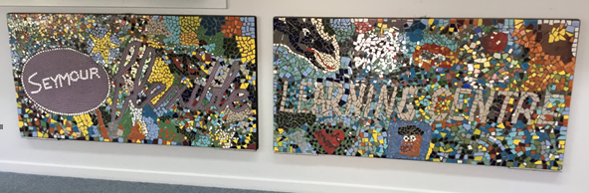
Term 2 - Issue 2
May, 2021
FROM THE PRINCIPAL | IMPORTANT DATES  14th – National Pirates Day.  25th – RAMS excursion  26th – Network Day for staff – school closed.  27th – Youth Law information session for students  June:  14th – Public Holiday  24th – Parent Teacher interviews – reports handed out  25th – End of Term 2  Term 3 starts July 12th.  Chin up programs runs every Friday, at 10.30, until the end of term. More information in the newsletter.
Term 2 Newsletter
An outstanding start for the term! A number of enquiries to enrol and several new students have started. Over the school break there was significant work being done to one of our classrooms with a new toilet and laundry area being constructed. The laundry area will be there for students to use.
Did you know that without a note or other documentation we have to mark young people with an ‘Unexplained Absence’. This is what Centrelink and government auditors look for in deciding whether a person is in fact a fulltime student. Please provide your mentor with a text message, phone message or written note so that we can provide an explanation on the roll. This will ensure your enrolment and avoid a Centrelink debt.

If you’re concerned about your child’s mental health, start by talking to your child. This might feel uncomfortable – you might even be waiting for the problem to go away. But talking to your child about how they are feeling shows them they are not alone and that you care. Also, your child might need your help to get professional support.
Here are some ideas to encourage your child to talk to you about how they’re feeling:
- Say that even adults have problems they can’t sort out on their own. Point out that it’s easier to get help when you have someone else’s support.
- Tell your child that it’s not unusual for young people to feel worried, stressed or sad. Also tell them that opening up about personal thoughts and feelings can be scary.
- Tell your child that talking about a problem can often help put things into perspective and make feelings clearer. Someone with more or different experience – like an adult – might be able to suggest options your child hasn’t thought of.
- Suggest some other people your child could talk to if they don’t want to talk to you – for example, aunts or uncles, close family friends, a trusted sports coach or religious leader, or your GP.
- Let your child know that talking with a GP or other health professional is confidential. They can’t tell anyone else, unless they’re worried about your child’s safety or someone else’s safety.
- Emphasise that your child isn’t alone. You’ll be there whenever they’re ready to talk.
If you raise your concerns with your child, they might refuse any help or say there’s nothing wrong. Many young people won’t seek help themselves. So, you might need to say that you’re worried about them and you’ll be trying to get professional advice. It’s a good idea to encourage your child to come with you. If they won’t, you might need to go on your own.
If you’re not sure what to do, a GP is a good place to start.
Have a great term.
Shane
For support call:
Lifeline 13 11 14;
Kids Helpline 1800 551 800; or Beyond Blue 1300 224 636.
LAUNDRY
Seymour FLC has Laundry facilities available if Students need to wash and/or Dry their clothes.

BUS
Bus Pick Up in the Mornings.
School bus does a student pick up each morning at 8.45. If you need a lift, text us and we will make sure you get picked up.
Well-Being
Hi everyone, I hope that you all had a lovely Easter break and are refreshed to start a brand-new term J From the 31st of May, parents and guardians of children and young people aged 4-18 can apply for sports vouchers from Get Active Victoria. Eligible families will be reimbursed up to $200 for things such as the cost of membership, uniforms and equipment. For more information on if your activity is eligible, please see https://www.getactive.vic.gov.au/vouchers/
Foodbank Victoria have a breakfast club program which gives students the opportunity to eat a wholesome, nutritious breakfast on a regular basis. By doing so, this has shown to have a positive impact on factors such our physical and mental health. We recently got a delivery onsite which includes prepacked food parcels, fresh apples, pears and oranges for students and families to take home. If you’re interested, please see a staff member J

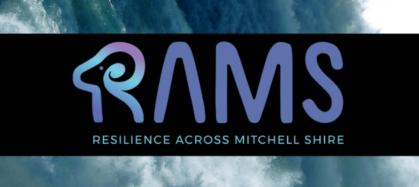
RAMS
RAMS students got to participate in the martial arts therapy workshop focusing on impulse control. The day was spent listening to facilitators exploring this theme, doing group activities and discussing the importance of responding to situations instead of reacting. Well done to all of our students for participating throughout the session J
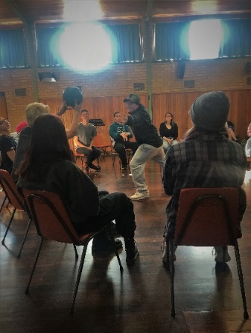

Chin Up
The hip-hop narrative workshop is currently running at Flexi by Todd from the Chin Up Project. This 10-week program has different themes each week based on identity, reflection, relationships and more. The program was created by youth workers to help students develop the tools to navigate through complex challenges in a creative way.

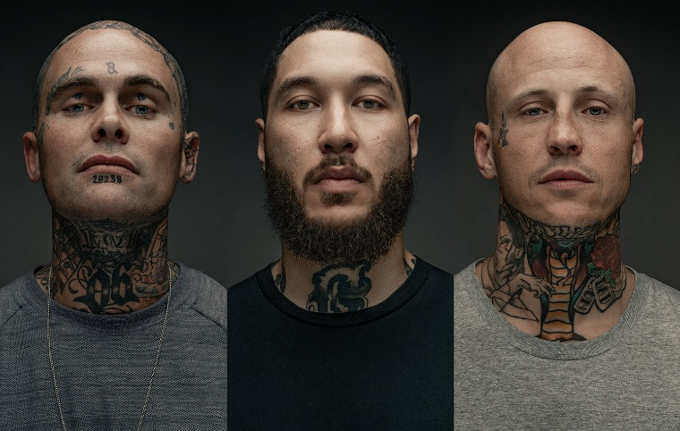

Clothes Swap
Kaylee, Tara and Ebony from Mitchell Shire Youth Services came in to collect donations for their clothes swap event happening May 15th at the Wallan Multi-Purpose Centre. Thank you so much to those who donated and participated in the giveaway! For more information on the clothes swap and donation points please visit https://www.mitchellshire.vic.gov.au/our-region/events/clothes-swap

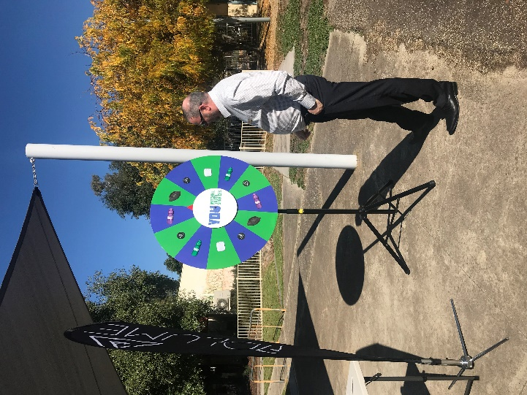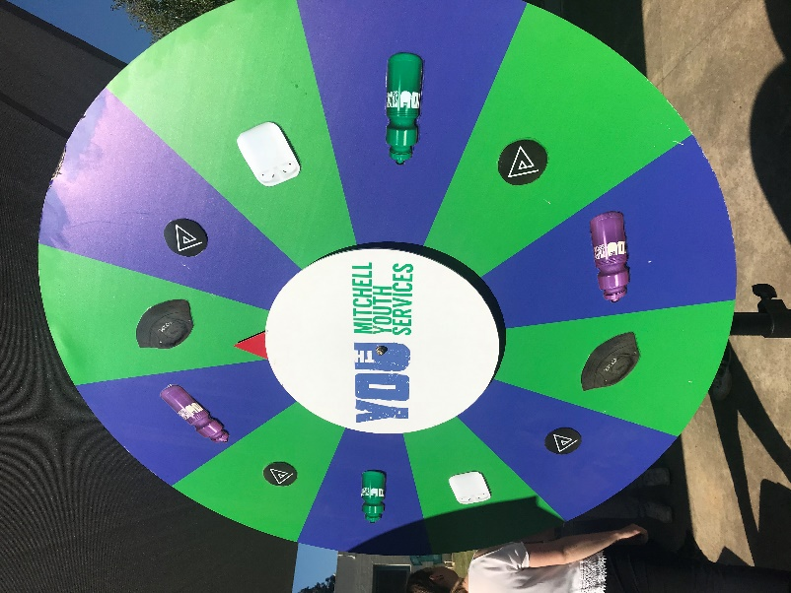

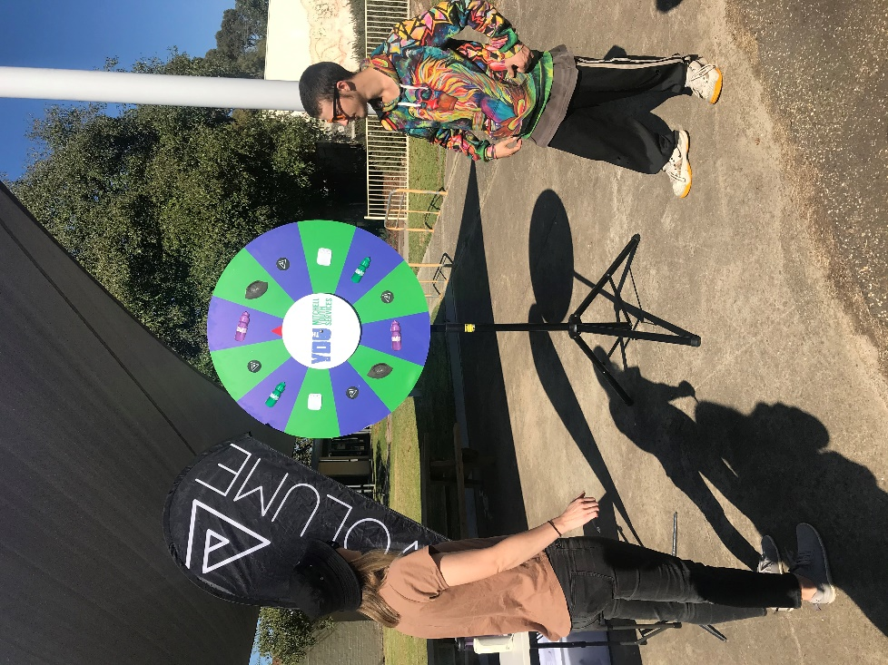

In the classroom

Melissa and Ash
VCAL – PDS Individual Projects
Over the last term students in VCAL have been working on planning and completing an individual project of their choice. Students should be commended on their efforts. Some amazing projects have been completed with many more in the final stages of production.

Hayley Edmonds
For our personal projects in PDS I chose to make a giant version of Jenga. Firstly, I had to measure out all of the pieces as precise as possible then began to cut all of them using a handsaw. Once the cutting was done, I sanded each piece to smooth and clean them up. After that was all complete, I rubbed linseed oil over them all to finish them off. All together I made up by 72 blocks of wood it makes up a height of 1.1 meters.

Max Martola
For my project in PDS I made a corn hole game board. I used an old table for the board. I started by cutting a hole in the board. Then I sanded the board and painted it. I also made 16 bean bags 4 for each player. At the end I cut the legs so it was on a slant and played a game with my classmates.

Dean

Survivor Day Competitions
Survivor what? Yes, that’s correct. This term we have been holding a “Survivor” themed day on Thursday’s based off of the successful TV series which is now a distant memory. For what conceivable purpose are we doing this? I hear you ask. Well, the number one reason is that it’s fun for both staff and students. “Fun…”! (Monty Pythonesque voice over). “You’re not supposed to have fun at school!”
“Rubbish!”. “Who asked you anyway, you, toffee nosed sap?” Yes, interactive team building and learning 21st century skills can be fun. At the very least, it’s a break from the typical routine of pen and paper/IT based work in the class room.
“So, what does it look like?” You ask.
Students have divided up into “Tribes”, or teams of around 4 or 5. They have taken on an identity with a tribe name, designed and produced a flag to represent themselves. Our morning and afternoon sessions feature a series of problem-solving activities which the Tribes apply themselves to and are scored according to how successful they were.
“What sort of ‘activities’?”
Activities have included: building a rope bridge, going on an orienteering treasure hunt around the school yard, crossing a lava field in “dodgy” boats, removing toxic waste, clearing a minefield whilst blindfolded, distilling sea water to make drinkable water, illustrating a comic by long distance telegraph, calculating area and volume of real-life shapes in the school yard and so on…
“What on Earth do they want to do that for? Get them back in the class room!”
Well, this is actually a rich learning experience for all involved. As you can already tell, some of the activities involve: the application of reading and written communication skills, a tonne of verbal communication between each member of the group to organize successful outcomes, fundamental numeracy like understanding angles and measurements of distance and degrees. Calculating surface area and volume.
Then there is another level of learning.
“Go on, enlighten me.”
Students have the opportunity to learn what employers are commonly referring to as 21st Century skills. These are particular “soft skills” which include: collaboration (teams working together to achieve a common goal), problem solving, exercising leadership, co-ordination and co-operation of team members, creative thinking, perseverance and resilience (the were withal to keep going), healthy competitiveness, civic responsibility, resourcefulness, self-direction and planning, analysing and synthesising information, entrepreneurialism, curiosity, imagination, innovation and personal expression to name a few.
At the conclusion of every Thursday a “Leader board” or ladder is pinned to the wall in the foyer to display where each of the tribes are currently placed in the competition. The current leaders are the “Nameless” tribe on 395 points. Although, that might change by the time this goes to print.
“So, where’s the evidence for all this?”
Just check out the photos…

Warm up exercise in Preparation for Survivor Day

Making Team Flags

Orienteering Treasure Hunt

Building a Rope Bridge

Different methods of crossing

Crossing a lava field

Removing Toxic waste Clearing a Minefield

Distilling sea water to make drinkable water

Illustrating a comic book by long distance telegraph
Students were shown a cartoon and then had to describe the cartoon verbally to the person drawing.

Calculating volume and area of real-life shapes in the school yard.

A Lens on Homelessness

This term in Dean’s class we have embarked on a unit of work investigating the circumstances of the homeless. We began by asking ourselves some questions about the way that we think and feel towards homeless people and challenged some of our pre-conceived ideas. Many of us realise that the amount of homeless people has been growing worldwide since the Covid pandemic hit. It is estimated that there is at least 116,000 people in Australia sleeping rough and at the last census count (in 2016) there were 3440 dads, mums, brothers and sisters, sons, daughters, friends… of someone, living on the streets of Melbourne; and that was 4 years ago!
Let’s be honest. Most of us walk past homeless people. But these are real people, with real issues. It has honestly been an eye opener to focus the lens in on some of these individuals. To spend a few minutes listening to their stories, to figuratively walk in their shoes. As well as viewing individual stories from those who have had to struggle with this soul-destroying reality, students have researched what services exist for the homeless in Victoria and Melbourne and what rights exist for those doing it tough on the streets. Don’t worry though it’s not all as bleak as an Opeth album cover. There are some really uplifting stories from individuals who have managed to overcome the odds. There are some great agencies out there providing crucial assistance and a handful of countries which are managing to eradicate homelessness all together. And that is inspirational stuff!
For a sneak peak into what we have been viewing go to YouTube and search up: “Swanston Street Stories – Homeless Melbourne Documentary” or “Rich Kids go Homeless – Josh”.

Or you can read a transcript which Lochlan compiled on a Sydney Man who suddenly found himself homeless:
Becoming homeless. It can happen to anyone and it does happen to anyone one should ever think that they are safe, that it’s is not going to happen. It could, and it can be just as easy as one thing. It may take an accumulation of things, but it does happen and it can happen to you as easily as anyone.
The man in the video whose name is Scott, he is 56 and he is from Mullumbimby.
Scott has been a teacher he has been a principal he was also the state manager of an it training company earning $50 an hour working 40 hours in a week.
In May, of 2013, he was diagnosed with a very aggressive form of cancer he had spent six months in hospital in Sydney, fighting that and obviously coming back, from that.
After his treatment he dealt with his own recovery on his own with very little assistance from anybody.
In 2015, Scott started to venture out into the world once again he was living with a friend and the situation there became extremely difficult and… one night Scott found himself homeless and, on the streets, himself and his dog in his car.
He gave his dog the back as well as whatever belongings he could get into the car.
He slept in the front seat he did not sleep because he was constantly on the lookout for somebody coming long.
This is what Scott had to say.
“It is very scary and it’s not something that you do because you want to, you have no other choice your world can collapse around you before you know it.
Once you suddenly have nowhere to go you don’t feel safe you don’t know what you’re going to do where you’re going to stay.
Your mind just can’t focus on anything you’re just overwhelmed. How am I going to live like this how am I going to get to sleep where is our food and water going to come from?”
The one thing he learned from this experience is don’t ever give up, never.
It can be difficult it can be daunting to ask for help but the difference is big.
Lochlan Draper.

Student Electives
TUESDAY AFTERNOON PROGRAM

Students have been participating in a number of activities on a Tuesday afternoon which have included art, wood work and cooking electives.
Activities so far have included making bird boxes and bird feeders, designing and making an insect hotel and participating in activities to commemorate Anzac Day.
Well done to all the students involved over the three weeks completed so far.

