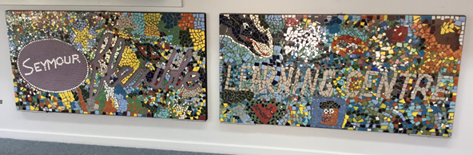
Term 1 - Issue 1
March, 2021
FROM THE PRINCIPAL |  | IMPORTANT DATES  30th March  Parent Teacher Interviews  Thursday 1st April  End of Term 1
Return to school from Covid 19 Circuit Breaker
Following the announcement from the Victorian Government on Wednesday 16th February, students returned to on-site learning on Thursday 18th February. It was great to see our students back at school.
Thank you for supporting your children and our school staff this week and let us hope we are able to make it through to the holidays without any further interruptions
Special congratulations to one of our students Hayley Edmonds who was named Young Citizen of the Year for a display of resilience during the past year. Hayley was cited for being ‘a natural leader’ and offered informal mentoring to her peers, who looked up to her during a disrupted year.
Mobile Phones
It is important to note that students are not to access their mobile phone during the school day as per department guidelines. If you need to contact your child please call the school office.
CSEF
The Camps, Sports and Excursions Fund helps eligible families to cover the costs of school trips, camps and sporting activities.
If you have a valid means-tested concession card, such as a Veterans Affairs Gold Card, Centrelink Health Care Card or Pensioner Concession Card, or are a temporary foster parent, you may be eligible. There is also a special consideration category for asylum seeker and refugee families.
Payment amounts this year are $225 for eligible secondary school students. Payments are made direct to the school to use towards expenses relating to camps, excursions and sporting activities for the benefit of your child.
If you applied for CSEF through our school last year, you do not need to complete an application form this year. If you did not fill in a form in 2020 and are eligible to receive CSEF in 2021 and would like to apply for the first time, please contact Tanya at the school office.
Stay safe and healthy.
Shane Elliott
Campus Principal.
WELCOME

We would like to take this opportunity to welcome our new students to the school.

Tanisha W
Quinn H
Connah H
Daniel H
Briodee B
Luke M

Welcome Back to Vikki.
Vikki will be returning from Maternity Leave two days a week next term. For the remainder of Term 1, she will be on site every Thursday Morning.
From the Office
It’s a pleasure to see all of your smiling faces. I hope you all had a lovely break and are feeling refreshed for the new year.
Just a few things
Change of Details forms
Please collect a change of details form if any of your details, ie phone number, address etc, have changed .

The Mitchell Shire have some events happening over the holiday period.
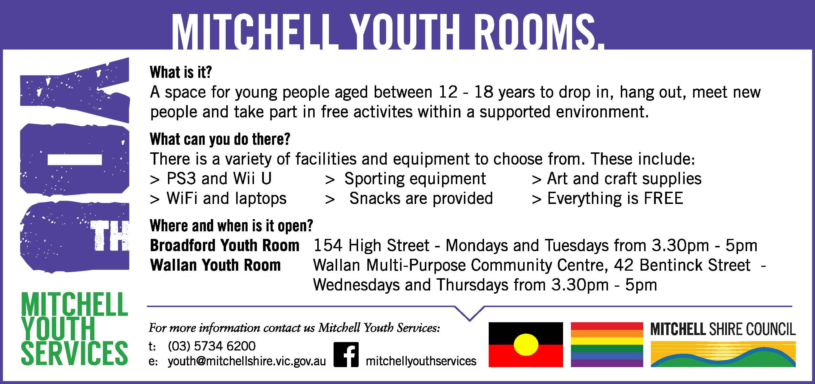

Forms are available at the office for the Pop Up Studio and Laser Skirmish.

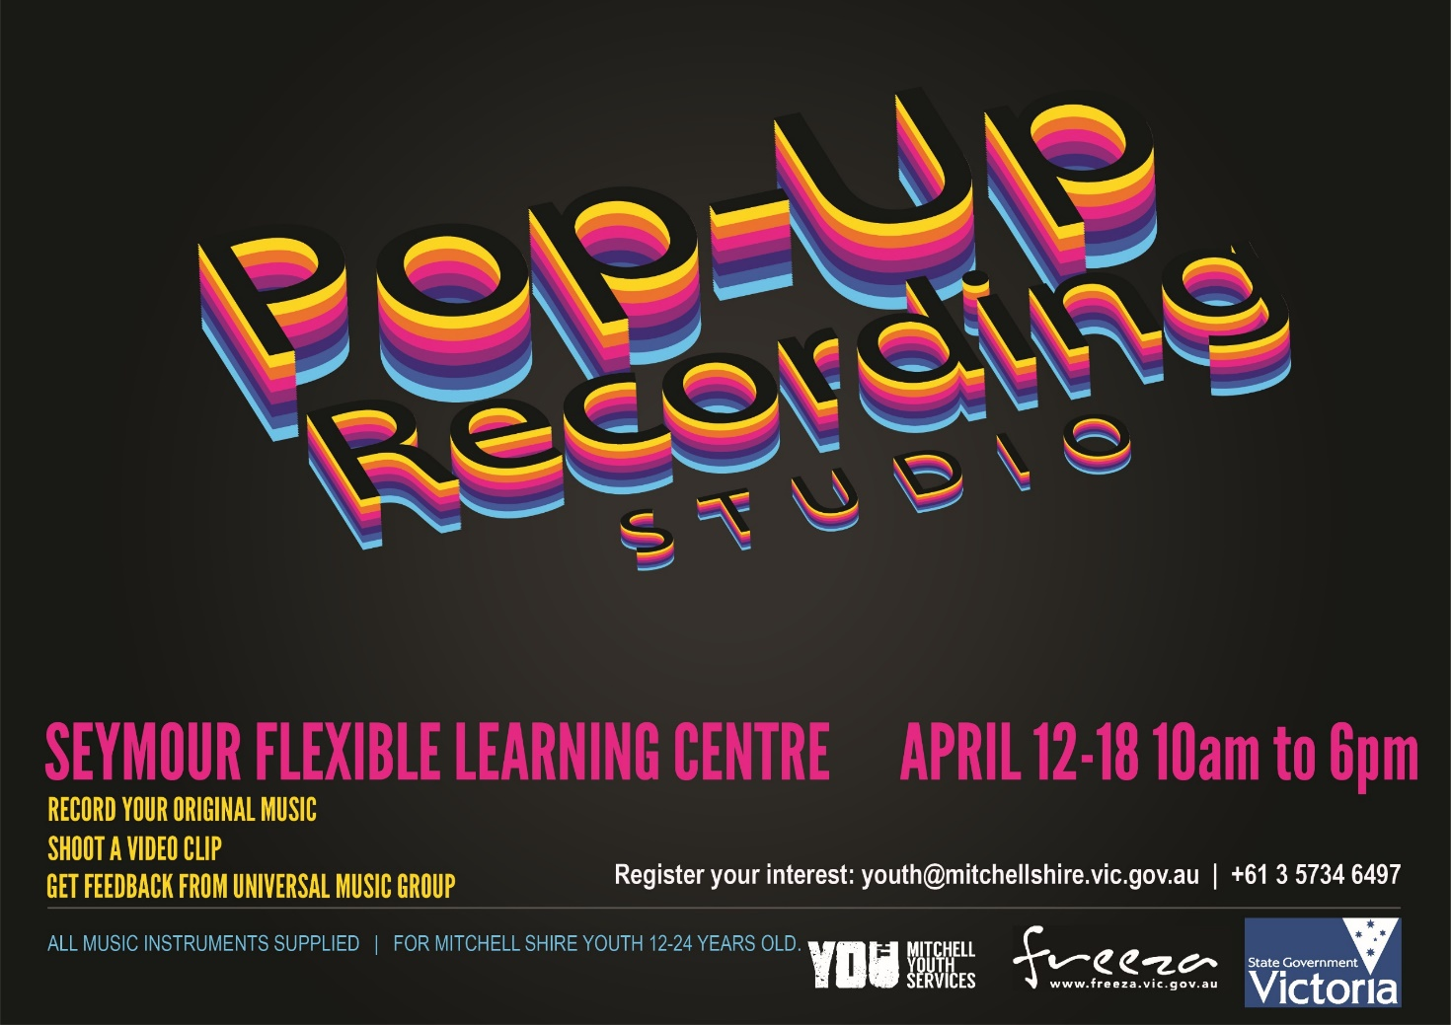
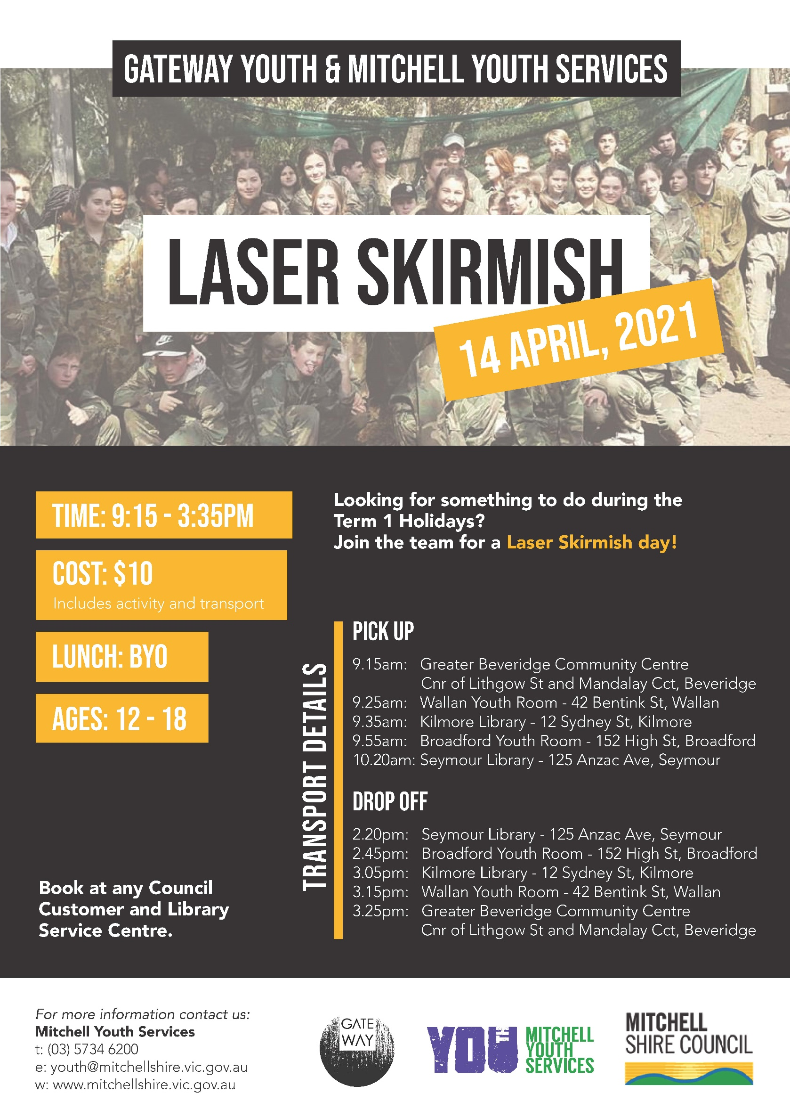

Careers
Pathways and Transitions update-
Term one kicked off with a bang. Animal Studies, Community Services, Business, Information Technology, Creative Industries, Automotive, Engineering, Active Volunteering & Building and Construction are all course that many students within the Seymour FLC are engaged and participating in during 2021. I wish them all luck in completing their chosen courses in partnership with the school curriculum.
During term one all students will complete at CAP. What is a CAP you ask?? A Career Action Plan (CAP) is completed every year to gain the students interests, pathway goals, future course/job options and looking at support the school can offer to the students in reaching these goals. CAP’s are a document that is updated through the year as the students reach career/goal milestones. These include short courses, casual employment, getting a license, work placement etc.
Please contact me if you have any questions or concerns in relation to careers, pathways and transition.
Regards, Jana. 0447 816 953

Well-Being

Welcome back everyone to a brand-new term at Seymour Flexi! I hope that you all had a safe and well-deserved break over the summer holidays. Starting a new school year can be incredibly daunting for some, especially given the difficult year that we all experienced in 2020. Now is a great time to set some achievable and realistic goals for the year, and start to establish a routine such as with your eating, sleeping and exercise. If you’re struggling mentally or physically, please reach out for assistance whether it be from myself, friends, family or a professional such as your GP or a counsellor. We now have access to regional phone counselling through Headspace during the school term which is completely confidential, so if you’re interested please come see me for a referral. See you around soon! ☺ – Sarah

Respectful Relationships
Respectful Relationships is an initiative to support schools and early childhood education settings promote and model respect and equality. It also supports educators to teach our children how to build healthy relationships, resilience and confidence.
On Tuesday the 9th March a Morning tea was held for students and staff to celebrate International Women’s Day.

The morning Tea commenced with a Brief talk about the meaning behind International Women’s Day.
Staff and students dined lavishly on Party Pies and cakes.

Thank you to all the students who attended.

In the classroom

Melissa and Ash
A huge welcome back to everyone for the start of 2021. It has been great to see everyone back and eager to get the year underway. Welcome to all the new students I hope you enjoy your time at the flexi.
Our Victorian Curriculum students have been revising number skills in Numeracy. We have been applying different strategies and challenging ourselves in mental math games. In Literacy we have been looking at Australian settlement and in particular the stories of Convicts. Students are writing a letter or journal entry detailing their experiences as a convict sentenced to transportation to Australia. We made some amazing aged paper to present our writing tasks on and are all super happy with the overall result.

In VCAL students have begun looking at current news stories for our ‘In the News’ session. This terms focus will be writing for self-expression. We have discussed conspiracy theories and completed our first VCOP assessment. In Numeracy the students are working on Graphs and Data. We have drawn a number of different types of graphs and also used Excel to enter data sets and produce graphs.
In PDS students have chosen and planned their own individual projects based on something they would like to learn, do or produce. It has been great to watch all students get involved in their projects and work hard to complete their individual tasks. We have a range of different activities being undertaken including origami, photography, art/ design, large board game construction and embroidery just to name a few. We look forward to sharing the finished projects with you in the coming weeks.

Well done to all students on a great start to the year.

Dean
Numeracy on Friday Mornings with Dean
Presently in “numeracy” my class are applying their knowledge of fundamental numeracy to construct chess boards from contrasting pine and Tasmanian Oak boards. Students have needed to measure in both metric and imperial. Preparing the segments to be cut and assembled has required some addition and division, (to cut the boards into equal lengths of four).
These segments have been glued and clamped together and last week we made a “stop” for our horizontal cuts on the panel saw. So far one board has been assembled into the “8 squared” checkerboard pattern but there is more to do yet. Measuring and cutting the base and sides remain.
Here are some shots of the student’s “numeracy” in action.

Student Electives
Cooking

The cooking elective has kicked off this term and has seen solid engagement from students. We have only been going for two weeks, but the students have churned out 4 incredible dishes. In the first week, they created a summer vegetable risotto, and some simple fruit and ricotta danish, and followed that up with some spring onion pancakes and a carrot and celery salad in week two. It’s great to see the students using techniques and ingredients that they haven’t used before.

Art
Well done to all students on a great start to the year. In Art students have been working on individual projects based on an area of interest many have chosen drawing or sculpture. Alongside this we have been creating small woven displays on weaving looms, decorating and painting pencil cases, looking at optical illusions and experimenting with clay.

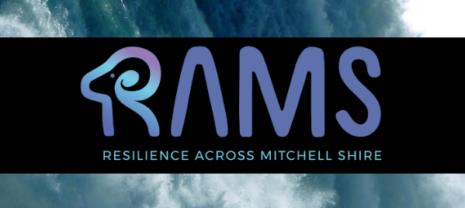
Students attended the first two sessions of RAMS for the term, which is a resilience building program for secondary students across Mitchell Shire. During the first session, we were able to learn about what resilience is, along with the skills that allow us to “bounce back” and succeed, despite what life might throw as us. Together we participated in activities with other students and staff members from local schools, and were able to listen and share our experiences and knowledge with others. The second session involved the students participating in the high rope’s activity at Kinglake Forest Adventures. The day consisted of fun warm up games and activities that allowed us to work together as a team to achieve the same goal. Our students were able to overcome mental and physical challenges with the support and encouragement from the entire group. It has been a very successful start to the program and we can’t wait to see what comes next!

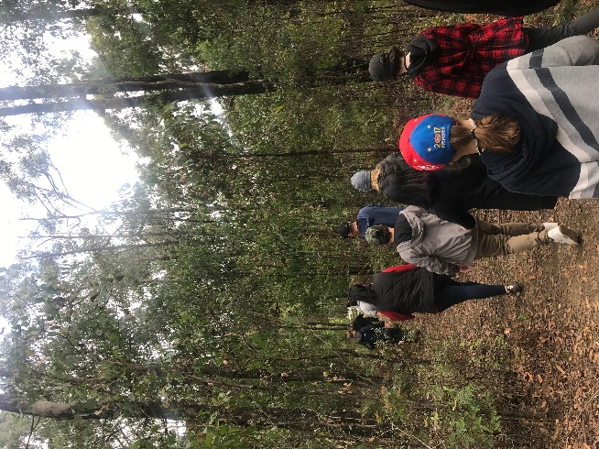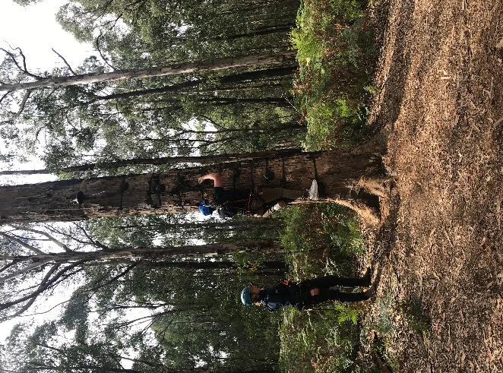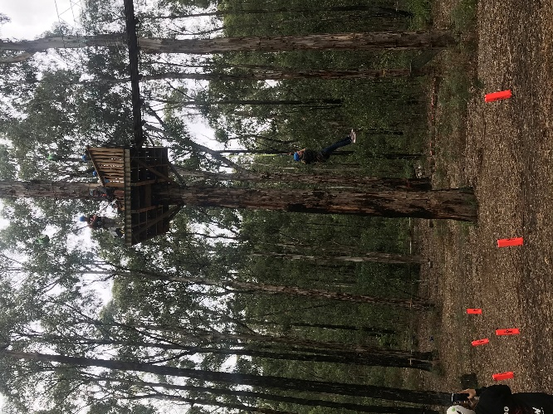

Billy Karts Excursion
On Thursday 25th February Lochlan & Aiden road tripped to Shepparton with Dean & Chris. After a slight detour around Shepparton we found the FLC new location, which looks great! Lochlan and Aiden joined some of their students for a fun filled morning incursion building Billy Karts, riding & then racing various Billy Karts. This was followed by a BBQ lunch.
It was great to catch up with Dianne & Anna who both say hello to you all.

